

**1 INTRODUCTION**

# **1.1 Overview**

Measuring success in talent management involves assessing how effectively an organization attracts, develops and retains its employees to achieve goals. Evaluating the quality of new hires in terms of skills, fit with company culture and performance. A successful talent management strategy should be dynamic and continuously adapted to meet evolving organizational needs and industry trends, emphasizing the critical role of human capital in driving business success.

# **1.2 Purpose**

Measuring success in talent management helps align talent management practices with the organization’s strategic goals and priorities. It allows identify areas where they excel in talent management and areas that require improvement. Success measurement helps identify high-performing employees and areas for improvement, leading to enhanced overall performance. Success measurement ensures that talent management practices are in sync with the organisation’s strategic objectives, ensuring that talent is contributing to the overall mission.

By analysing success metrics, organizations can refine their recruitment processes to attract and hire candidates who are more likely to excel in their roles, reducing turnover and recruitment costs. Measurement allows for the identification of skill gaps and training needs, leading to targeted employee development programs that increase competencies and career progression.

**2 PROBLEM DEFINITION & DESIGN THINKING**

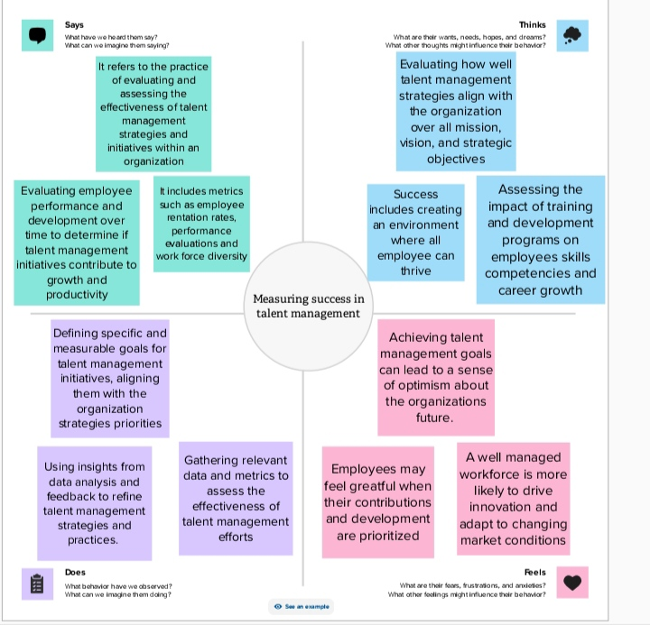**2.1 Empathy map**

# **2.2 Ideation & Brainstorming Map**

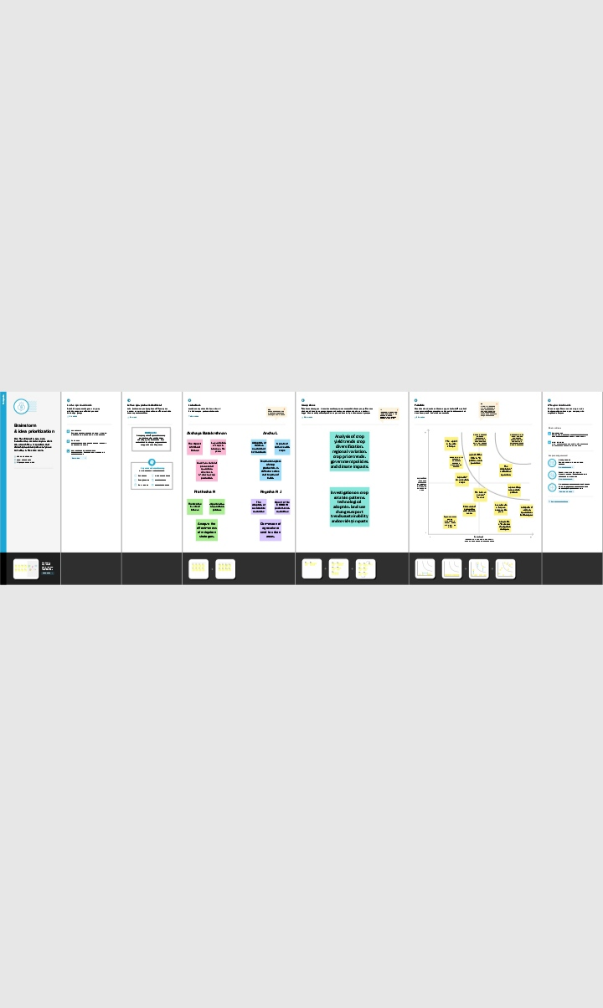

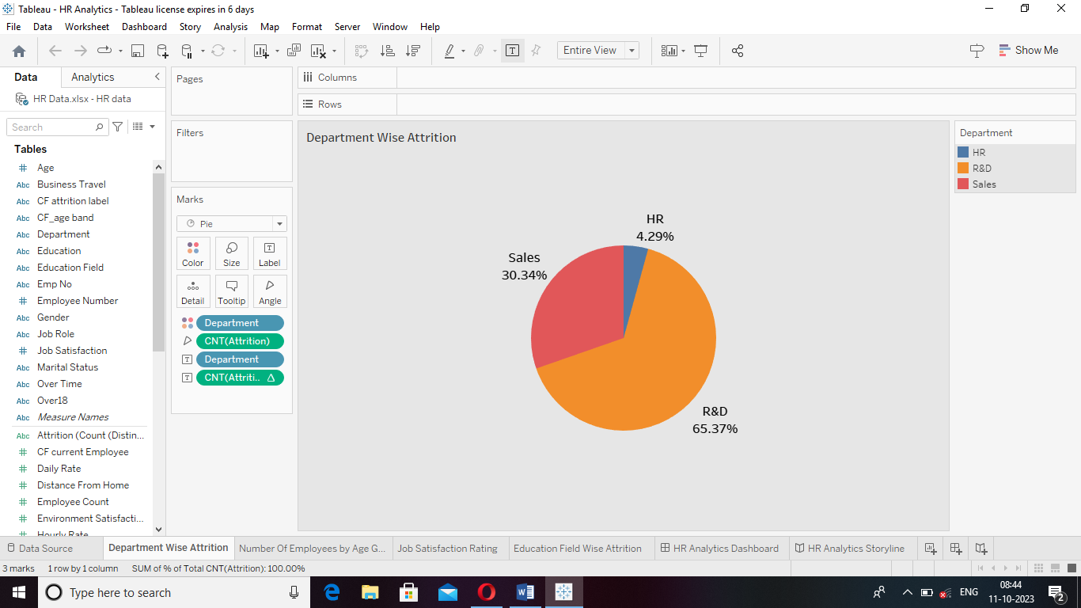**3 RESULT**

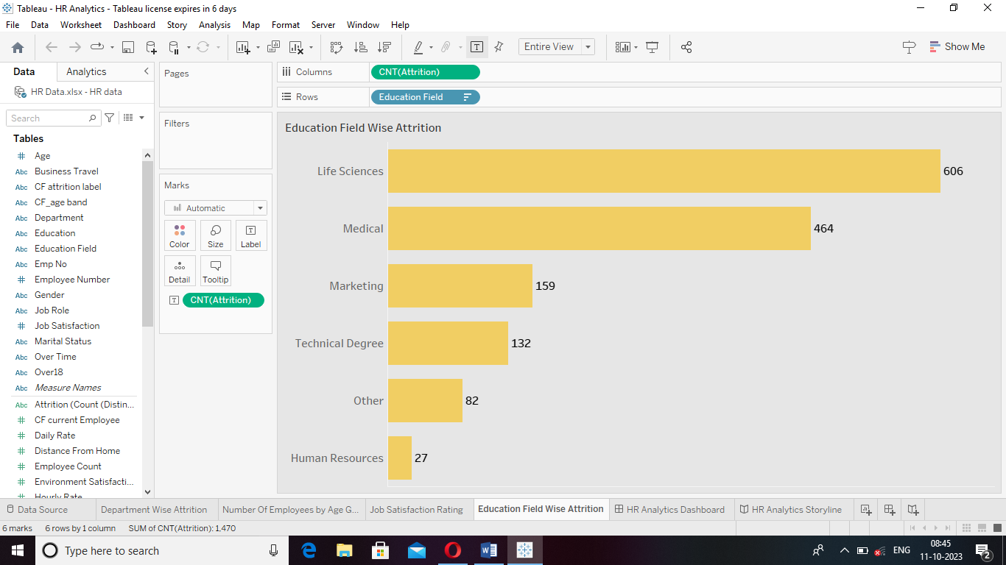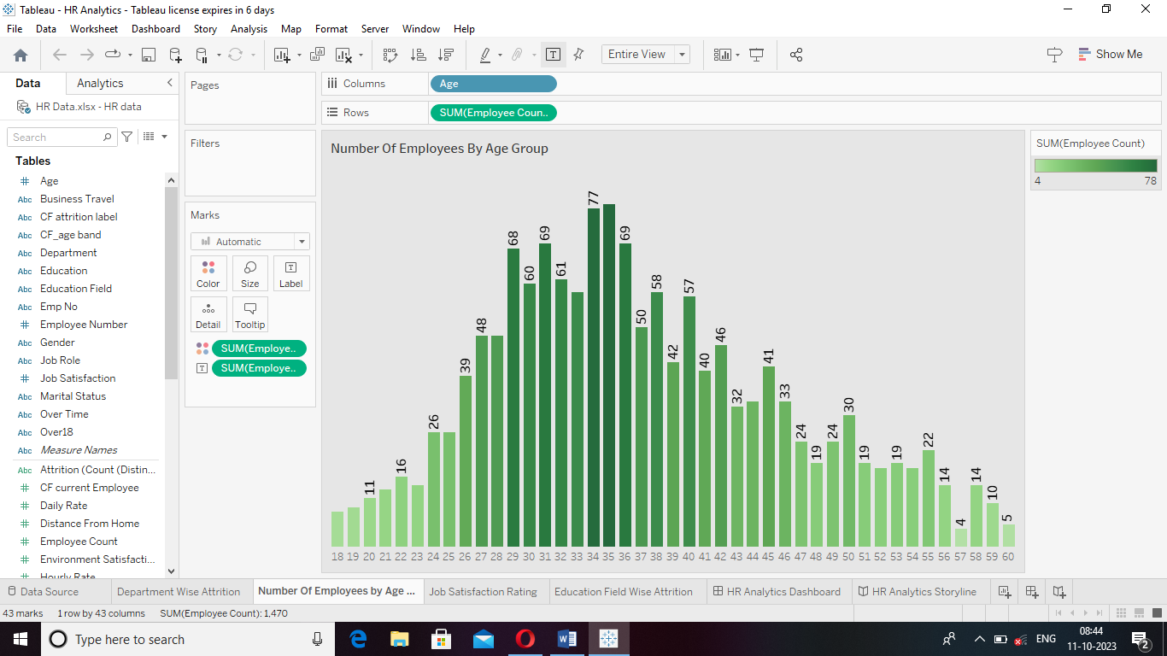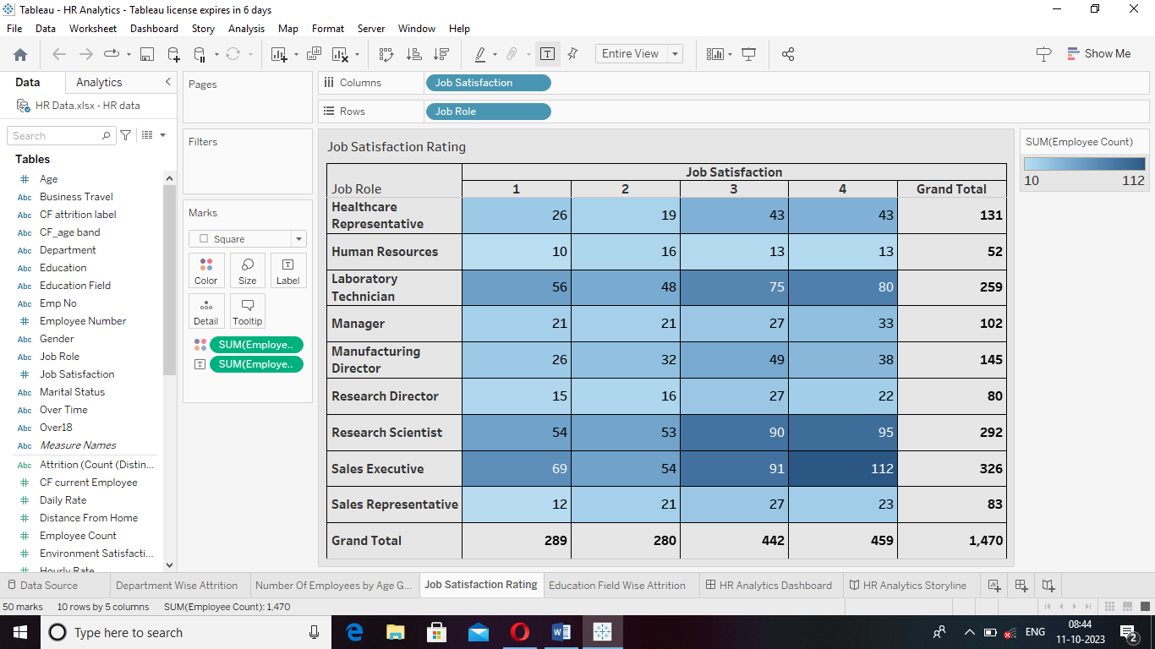

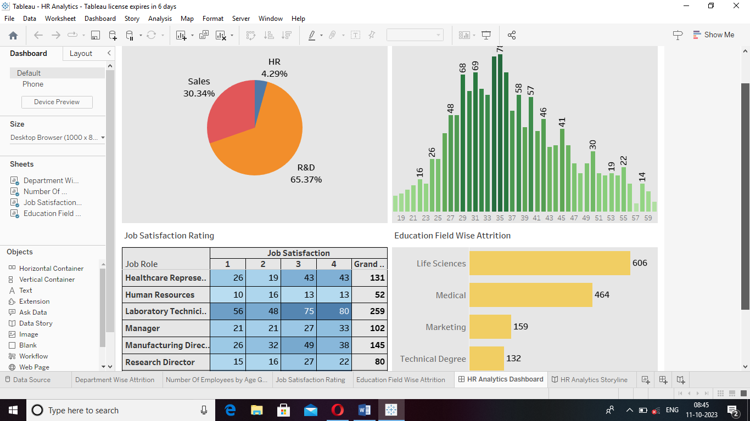HR Analytics Dashboard

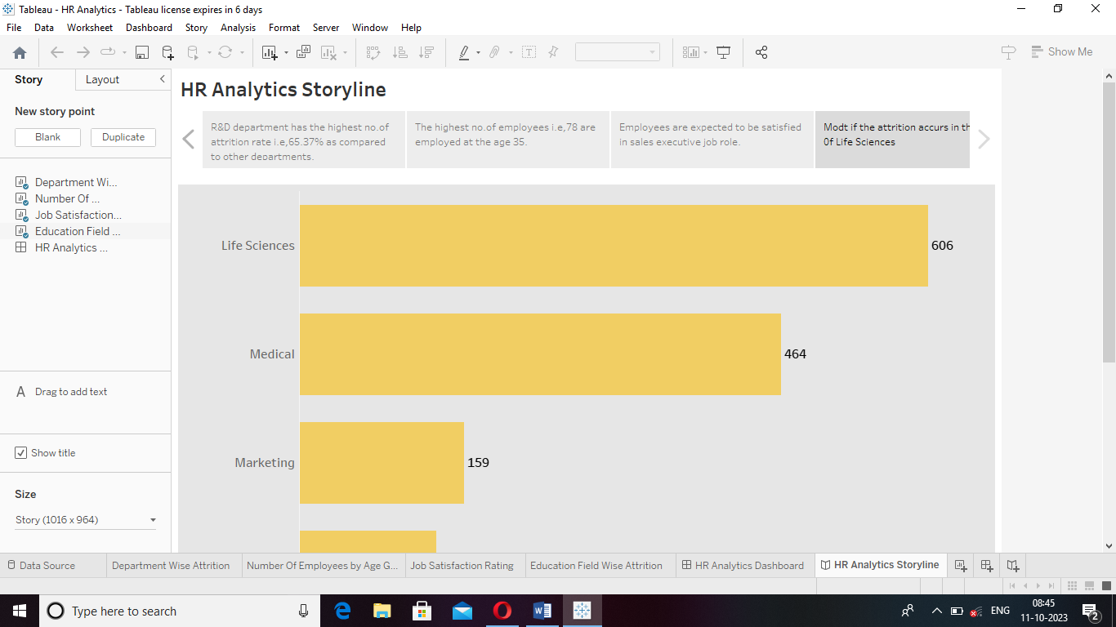HR Analytics Storyline

**4 ADVANTAGES & DISADVANTAGES**

## **Advantages**

* It provides data-driven insights to make informed decisions about recruitment, development and retention.
* Allows for identifying and nurturing high-potential talent, leading to improved employee performance and productivity.
* Helps in reducing turnover and the costs associated with recruitment and training by retaining top talent.
* Ensure that talent management efforts align with organizational goals and objectives.
* A strong talent management process can give a company a competitive edge in the marketplace.

## **Disadvantages**

* Setting overly ambitious goals can put undue pressure on employees and lead to burnout or unethical behaviour.
* The accuracy of the data used for measurement can be a challenge, and unreliable data can lead to incorrect conclusions.
* Employees and managers may resist the introduction of performance metrics if they perceive them as intrusive or counterproductive.
* When individuals or teams are ranked based on metrics, it can create unhealthy internal completion and hinder collaboration.
* Metrics may encourage a short-term mindset, where immediate gains or prioritized over long-term talent development and strategic planning.

**5 APPLICATIONS**

Assess the effectiveness of the hiring processes by tracking metrics such as time-to-fill, quality of hires, and cost per hire. Track turnover rates to evaluate your ability to retain top talent. Low turnover can be a sign of successful talent management. Measure the readiness of internal candidate to take on leadership roles through development programs and promotion rates. Assess the impact of training programs on employee skill development and career progression.

**2 CONCLUSION**

The study of measuring success in talent management reveals that a multi-faceted approach is essential for understanding and enhancing talent management outcomes. Success in talent management cannot be boiled down to a single metric, but rather depends on a combination of factors. These factors include effective recruitment, development, retention, and alignment with organizational goals. Additionally, measuring success should involve both quantitative and qualitative assessments, considering key performance indicators and employee satisfaction, among other variables. Continuous evaluation and adaptation of talent management strategies are crucial for achieving long-term success. The findings the underscore the complexity of talent management and the need for a holistic and adaptable approach to ensure organizations effectively nurture and leverage their human capital for sustained success.

**7 FUTURE SCOPE**

Utilize advanced analytics and machine learning to predict the success of talent management initiatives. This could involve forecasting the impact of different strategies on key performance indicators. Move beyond traditional metrics like turnover rates and employee satisfaction. Consider a more holistic approach that includes measuring factors like employee well-being, diversity and inclusion, and the alignment of talent strategies with overall business objectives.